SIMPLE CONTACT BOOK
@CREATIVITY THINK (9483175986/7019689991)

ABSTRACT:
Simple Contact Book is a web-based application designed for personal information management. The platform enables users to add, edit, delete, and search contacts efficiently, with details such as phone numbers and email addresses. Built using Django for backend operations and React with axios for the frontend, the system ensures real-time updates and smooth interaction. Administrators can manage users and perform CRUD operations. This lightweight and dynamic web app serves as a personal information tracking tool, providing ease of use, reliability, and secure data handling..

INTRODUCTION OF THE PROJECT:
Managing contacts manually or via multiple applications can be time-consuming and inefficient. Simple Contact Book addresses this problem by providing a centralized, dynamic web application for tracking personal contacts. Users can create, modify, or remove contacts and quickly search for any record using phone numbers or email addresses. Administrators maintain oversight by managing user accounts and performing CRUD operations. The system’s simple interface and fast performance make it ideal for personal and small-scale use..

PROJECT OBJECTIVES:

• Allow users to create, edit, and delete contact entries
• Enable quick search by name, phone number, or email
• Provide a dynamic interface for real-time updates
• Allow administrators to manage users and perform CRUD operations
• Ensure data is stored securely and efficiently
• Offer a lightweight, user-friendly application suitable for personal use

PROBLEM OF THE STATEMENT:
Many individuals rely on multiple tools or paper-based records for storing contact information, which often leads to lost or inconsistent data. Existing applications may be too complex or require subscription services. Simple Contact Book provides a minimalistic, dynamic solution that is free, lightweight, and easy to use, ensuring all contacts are organized and accessible in one platform..

MOTIVATION OF THE PROJECT:
• To provide a simple and efficient tool for personal contact management
• To reduce dependency on physical notebooks or multiple applications
• To allow quick access and modification of personal contacts
• To provide administrators with the ability to manage user access
• To create a lightweight and fast web application suitable for personal use

BLOCK DAIGRAM OF PROJECT:

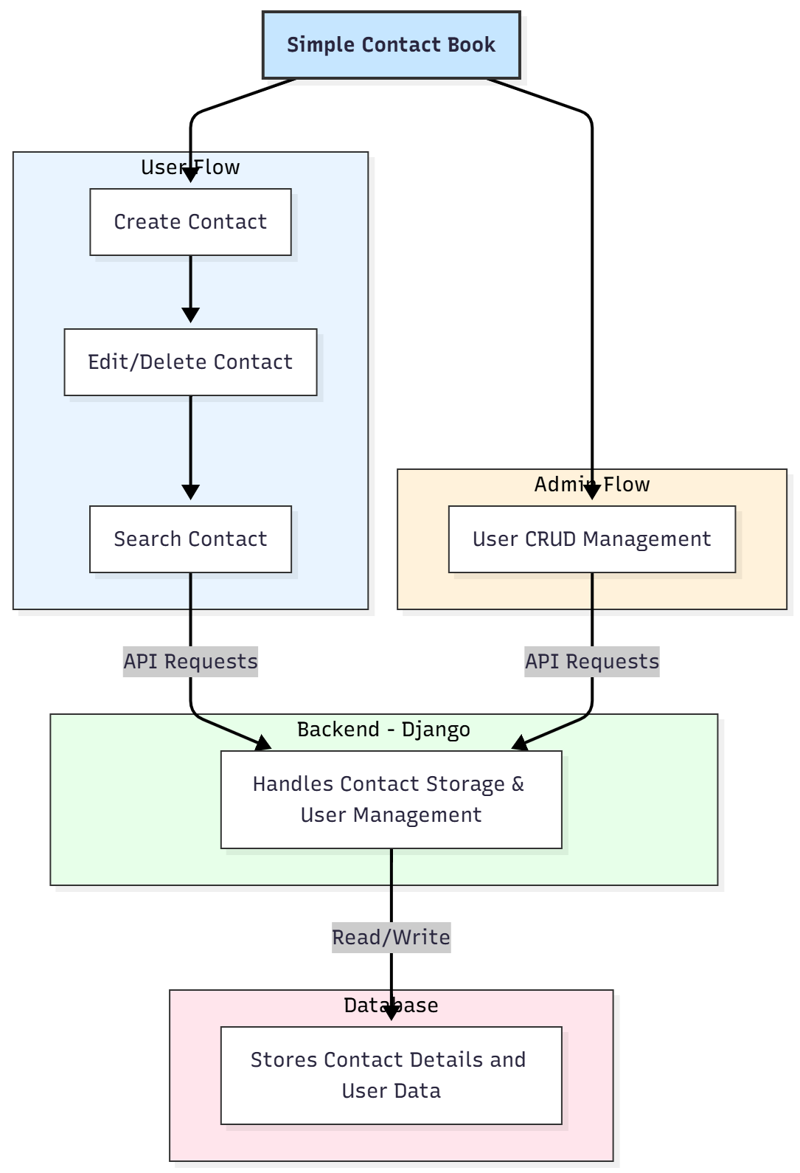

WORKING OF THE PROJECT:
Users start by creating a new contact with name, phone number, and email. Existing contacts can be edited or deleted. The search feature allows quick retrieval of any contact using the stored details. All operations are handled dynamically through Django APIs, and React updates the interface in real time. Administrators manage users and can perform CRUD operations, ensuring proper user access. The database stores all contact and user information securely, enabling a smooth and efficient personal contact management system..

SOFTWARE REQUIREMENT:
- Backend:
  - Python 3.x
  - Django
  - Django REST Framework
  - SQLite/PostgreSQL
- Frontend:
  - Node.js and npm
  - React.js
  - Axios
- Development Tools:
  - Visual Studio Code
  - Postman (for testing APIs)
  - Git/GitHub (for version control)
- Server/Deployment (Optional):
  - Gunicorn, Nginx, or Heroku/AWS for hosting

ADVANTAGES OF THE PROJECT:

• Easy creation, editing, and deletion of contacts
• Quick search functionality for faster access
• Dynamic interface with real-time updates
• Administrator access for user management
• Secure storage of personal data
• Lightweight and fast web application
• Free and simple to use for personal purposes

APPLICATIONS OF THE PROJECT:
• Personal contact tracking
• Small-scale information management
• Education or research projects requiring personal data management
• Basic CRM functionality for small teams

REFERENCES:

- Django REST Framework Documentation — Django Software Foundation. Django Documentation. Available: https://docs.djangoproject.com/
- Django REST Framework. DRF Documentation. Available: https://www.django-rest-framework.org/
- React. React Official Documentation. Available: https://reactjs.org/docs/getting-started.html
- Redux. Redux Documentation. Available: https://redux.js.org/introduction/getting-started
- PostgreSQL Global Development Group. PostgreSQL Documentation. Available: https://www.postgresql.org/docs/
- MySQL. MySQL Reference Manual. Available: https://dev.mysql.com/doc/
- Git. Git Documentation. Available: https://git-scm.com/doc
- Node.js. Node.js Documentation. Available: https://nodejs.org/en/docs/
- Axios. Axios Documentation. Available: https://axios-http.com/docs/intro
- Socket.io Documentation – https://socket.io/docs/

